|  |  |  |  |
| --- | --- | --- | --- |
| **TABLE OF CONTENTS** | | | |
|  |  | ***Title*** | ***Page No.*** |
|  | **TABLE OF CONTENTS** | | 04 |
| **1** | **INTRODUCTION** | |  |
|  | 1.1 Project Idea | | 12 |
|  | 1.2 | Overview | 13 |
|  | 1.3 | Modules | 14 |
| **2** | **SOFTWARE REQUIREMENT SPECIFICATION** | | |
|  | 2.1 Introduction | | 16 |
|  | 2.2 Functional Requirements | | 17 |
|  | 2.3 Non Functional Requirements | | 19 |
|  | 2.4 | Hardware Requirements | 22 |
|  | 2. 5 Software Requirements | | 22 |
| **3** | **ANALYSIS AND DESIGN PHASE** | |  |
|  | 3.1 Introduction | | 25 |
|  | 3.2 Class Diagram | | 25 |
|  | 3.3 | Object Diagram | 26 |
|  | 3.4 | Activity Diagram | 27 |
|  | 3.5 | Sequence Diagram | 28 |
|  | 3.6Collaboration Diagram | | 29 |
|  | 3.7State chart Diagram | | 30 |
| 3.8 Component Diagram | | | 31 |
|  | 3.9Deployment Diagram | | 31 |
|  | 3.10 Data Design | | 32 |
|  | 3.11 Conclusion | | 35 |

|  |  |
| --- | --- |
| **4 SYSTEM LOW LEVEL DESIGN** |  |
| 4.1 Modules of the project | 37 |
| 4.2 Objectives | 37 |
| 4.3 Project overview | 38 |
| **5 IMPLEMENTATION** |  |
| 5.1 Same Code | 41 |
| 5.2 Screen Captures | 52 |
| 5.3 Firebase Analytics | 59 |
| **6 TESTING** |  |
| 6.1 Software Testing | 63 |
| 6.2 Black Box Testing | 63 |
| 6.3White Box Testing | 63 |
| 6.4 Performance Testing | 63 |
| 6.5Load Testing | 63 |
| 6.6Manual Testing | 63 |
| 6.7Firebase Test Lab | 67 |
| **7 RESULTS AND CHALLENGES** |  |
| 7.1 Results | 70 |
| 7.2Challenges | 70 |
| **8 CONCLUSION AND FUTURE WORK** |  |
| 8.1 Conclusion | 72 |
| 8.2Scope for future work | 72 |
| 8.3Limitations | 72 |
| **BIBILOGRAPHY** | 73 |

## LIST OF FIGURES

|  |  |  |
| --- | --- | --- |
| **FIGURE NO** | **TITLE** | **PAGENO** |
| 2.1 | Use Case Diagram | 21 |
| 3.2 | Class Diagram | 25 |
| 3.3 | Object Diagram | 26 |
| 3.4 | Activity Diagram | 27 |
| 3.5 | Sequence diagram | 28 |
| 3.6 | Collaboration diagram | 29 |
| 3.7 | State Chart diagram | 30 |
| 3.8 | Component diagram | 30 |
| 3.9 | Deployment diagram | 31 |
| 5.2.1 | User login screen | 52 |
| 5.2.2 | Forgot password page | 52 |
| 5.2.3 | User sign up page | 53 |
| 5.2.4 | User home screen | 53 |
| 5.2.5 | Service page | 54 |
| 5.2.6 | Booking page | 54 |
| 5.2.7 | All bookings page | 55 |
| 5.2.8 | Referral page | 55 |
| 5.2.9 | User profile page | 56 |
| 5.2.10 | Service provider login page | 56 |
| 5.2.11 | Service provider signup page | 57 |
| 5.2.12 | Service provider bookings | 57 |
| 5.2.13 | Reference page | 58 |
| 5.2.14 | Service provider profile page | 58 |
| 5.3.1 | Firebase Authentication | 59 |
| 5.3.2 | Password reset mail template | 59 |
| 5.3.3 | Firebase Database | 60 |
| 5.3.4 | Active sessions | 60 |
| 5.3.5 | User engagement | 61 |

|  |  |  |
| --- | --- | --- |
| 6.1 | Test case for empty login | 64 |
| 6.2 | Test case for wrong login | 65 |
| 6.3 | Test case for signup fail | 66 |
| 6.4 | Test case for user signup fail | 67 |
| 6.7 | Firebase test lab clusters | 68 |

**LIST OF TABLES**

|  |  |  |
| --- | --- | --- |
| Table 3.10.1 | SQLite Database | 32 |
| Table 3.10.2 | List of tables in database | 32 |
| Table 3.10.3 | Admin table | 32 |
| Table 3.10.4 | Users table | 33 |
| Table 3.10.5 | Service providers table | 33 |
| Table 3.10.6 | Bookings table | 34 |
| Table 3.10.7 | Services table | 34 |
| Table 6:1 | Test case for empty login fields | 64 |
| Table 6:2 | Test case for wrong login fields | 64 |
| Table 6:3 | Test case for signup fail | 65 |
| Table 6:4 | Test case for User signup fail | 67 |

**ACRONYMS & ABBREVIATIONS**

|  |  |
| --- | --- |
| * **HTML:** | Hyper Text Markup Language. |
| * **XML:** | Extensible Markup Language. |
| * **IDE:** | Integrated Development Environment |
| * **PHP:** | Hyper Text Preprocessor |
| * **RDBMS:** | Relational Database Management System. |
| * **GUI:** | Graphical User Interface |
| * **HTTP:** | Hyper Text Transfer Protocol |
| * **API:** | Application Programming Interface |
| * **E-R:** | Entity-Relationship |
| * **UML:** | Unified Modeling Language |
| * **OOAD:** | Object-Oriented Analysis & Design. |

**INTERNSHIP SUMMARY**

**Location:**Hyderabad

**Center:** “Name of the organization”

**Duration:**

**Date of start:**

**Date of submission:**

**Title of project:**

**Team Members:**

xxxxxx(151FA0xxxx) xxxxxx(151FA0xxxx) **Name of the guide:**

**Name of Faculty guide:** VFSTR University. **Project Area: Online Depression Detection**

**Abstract:**

* In this project we are detecting depression from users post, user can upload post in the form of text file, image file or audio file, this project can help peoples who are in depression by sending motivated messages to them. Now-a-days peoples are using online post services to interact with each other compare to human to human interaction. So by analysing users post this application can detect depression and send motivation messages to them. Administrator of this application will send motivation messages to all peoples who are in depression. To detect depression we are using SVM (support vector machine) algorithm which analyse users post and give result as negative or positive. If users express depression words in post then SVM detect it as a negative post else positive post.

**Signature of Student Signature of Faculty Guide**

**Date: Date:**

# PROFILE OF THE COMPANY

**About ECIL**

**Electronics Corporation of India Limited (ECIL)** is a Government of India Enterprise under the Department of Atomic Energy, established on April 11, 1967 by A. S. Rao at Hyderabad, to create a strong indigenous base in electronics. ECIL is a multi-product, multi- disciplinaryorganization with focus on indigenous Nuclear energy, space and Defense sectors. ECIL also has a strong presence in indigenous Electronic Security, Communications, Networking and e-governance domains. ECIL has committed partnerships with nuclear energy establishments of India, particularly Bhabha Atomic Research Center (BARC), Nuclear Power Corporation of India Limited (NPCIL) and Indira Gandhi Centre for Atomic Research (IGCAR). ECIL also actively supports other strategic sectors such as indigenous Defense (Defense Research and Development Organization(DRDO)), Space (Department of Space (India))Civil Aviation, Information and Broadcasting, Telecommunications, Insurance, Banking, Police and Para-military Forces, Oil and Gas, Power, Space Education, Health, Agriculture, Steel and Coal. ECIL is credited with producing the first indigenous digital computers, TDC 312 and TDC 316, solid state TV, control and instrumentation for nuclear power plants and first earth station antenna of India.

**Company address:**

A.S. Rao Nagar, ECIL, Hyderabad

***CHAPTER - 1***

***INTRODUCTION***

*The chapter gives brief introduction of the project.*

## CHAPTER 1 INTRODUCTION

* The proliferations of internet and communication technologies, especially the online social networks have rejuvenated how people interact and communicate with each other electronically. The applications such as Facebook, Twitter, Instagram and alike not only host the written and multimedia contents but also oﬀer their users to express their feelings, emotions and sentiments about a topic, subject or an issue online. On one hand, this is great for users of social networking site to openly and freely contribute and respond to any topic online other hand, it creates opportunities for people working in the health sector to get insight of what might be hap- pening at mental state of someone who reacted to a topic in a speciﬁc manner. In order to provide such insight, machine learning techniques could potentially oﬀer some unique features that can assist in examining the unique patterns hidden in online communication and process them to reveal the mental state (such as ‘happiness’, ‘sad- ness’, ‘anger’, ‘anxiety’, depression) among social networks’ users. Moreover, there is growing body of literature addressing the role of social networks on the structure of social relationships such as breakup relationship, mental illness (‘depression’, ‘anxiety’, ‘bipolar’ etc.), smoking and drinking relapse, sexual harassment and for suicide ideation

***CHAPTER - 2***

***SOFTWARE REQUIREMENT***

***SPECIFICATION***

*Gives the details of platform specifications, Hardware,and Software specifications.*

## CHAPTER 2 REQUIREMENT ANALYSIS

This chapter provides the details of the project’s need based survey, system requirements, Hardware Requirements, Software Requirements, and System Requirements.

**Project Overview :-**

* In this project we are detecting depression from users post, user can upload post in the form of text file, image file or audio file, this project can help peoples who are in depression by sending motivated messages to them. Now-a-days peoples are using online post services to interact with each other compare to human to human interaction. So by analysing users post this application can detect depression and send motivation messages to them. Administrator of this application will send motivation messages to all peoples who are in depression. To detect depression we are using SVM (support vector machine) algorithm which analyse users post and give result as negative or positive. If users express depression words in post then SVM detect it as a negative post else positive post.

**Existing System :-**

* detecting depression from users post, user can upload post in the form of text file, image file or audio file, this project can help peoples who are in depression by sending motivated messages to them. Now-a-days peoples are using online post services to interact with each other compare to human to human interaction.
* we aim to analyze Facebook data to detect any factors that may reﬂect the depression of rel- evant Facebook’s users. Various machine learning techniques are employed for such purpose. Considering the key objective of this study, the following are subsequent research challenges addressed in paper.
* As users express their feeling as a post or comments in the Face-book platform, sometimes their posts and comments refer to as emotional state such as ‘joy’, ‘sadness’, ‘fear’, ‘anger’, or ‘surprise’ .

**Proposed System :-**

* To implement this project we are using python Speech Recognition API which will read text from audio files and then SVM will analyse that text to detect depression, user can also upload images via post and python Tesseract OCR (Optical Character Recognition) API can read text from uploaded image and then SVM will detect depression from that text, User can upload post in text file also.

**Advantages :-**

* Security
* Communcation .

**Functional requirements :-**

In software engineering, a functional requirement defines a system or its component. It describes the functions a software must perform. A function is nothing but inputs, its behavior, and outputs. It can be a calculation, data manipulation, business process, user interaction, or any other specific functionality which defines what function a system is likely to perform.

Functional software requirements help you to capture the intended behavior of the system. This behavior may be expressed as functions, services or tasks or which system is required to perform.

**Non –Functional Requirements :-**

A non-functional requirement defines the quality attribute of a software system. They represent a set of standards used to judge the specific operation of a system. Example, how fast does the website load?

A non-functional requirement is essential to ensure the usability and effectiveness of the entire software system. Failing to meet non-functional requirements can result in systems that fail to satisfy user needs.

**Hardware Requirements :-**

* Operating System supported by

1. Windows 7

2. Windows XP

3 . Windows 8

* Processor – Pentium IV or higher
* RAM -- 256 MB
* Space on Hard Disk -- Minimum 512 MB

**Software Requirements :-**

* For developing the Application

1. Python

2. Django

3. Mysql

4. Mysqlclient

5. WampServer 2.4

* Technologies and Languages used to Develop

-- Python

### HOME PAGE:-

* XML
* JAVA

### REGISTRATIONPAGE:-

* XML
* JAVA

### LOGIN PAGE:-

* XML
* JAVA

### BOOKINGS PAGE

* XML
* JAVA

### REFERRALS PAGE

* XML
* JAVA

### PROFILE PAGE

* XML
* JAVA

### PREFERENCE PAGE

* XML
* JAVA

### SP LOGIN PAGE

* XML
* JAVA

### SP SIGN UP PAGE

* XML
* JAVA

### SP BOOKING PAGE

* XML
* JAVA

***CHAPTER - 3***

***ANALYSIS & DESIGN***

*This chapter gives the details of the system and data design.*

### CHAPTER 3 DESIGN PHASE

**INTRODUCTION**

This chapter provides the design phase of the Application. To design the project, we use the UML diagrams. The Unified Modelling Language (UML) is a general- purpose, developmental, modelling language in the field of software engineering that is intended to provide a standard way to visualize the design of a system.

### 3.1 USE CASE DIAGRAM

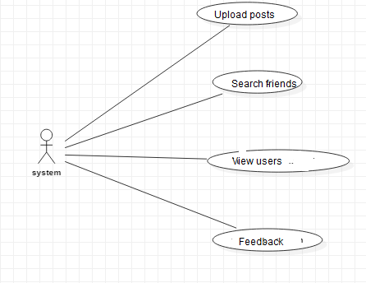

**Fig 2.1 Use case Diagram**

The use case diagram is used to represent all the functional use cases that are involved in the project.

The above diagram represents the main two **actors** in the project, they are

* + - User

### CLASS DIAGRAM

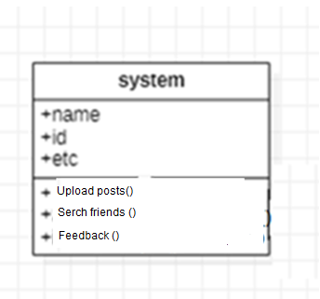

**Fig 3.2 class diagram**

The above mentioned class diagram represents the Chatbot system workflow model. This diagram has class models with class names as

* + - User
    - Admin
    - Home screen

### SEQUENCE DIAGRAM

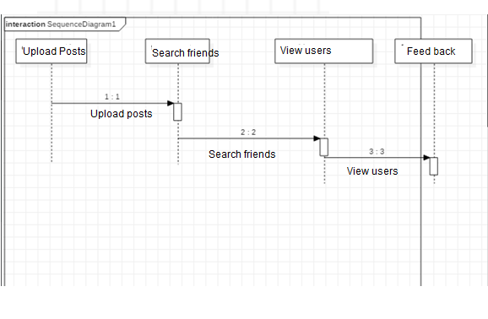

**Fig 3.5 sequence diagram**

The above diagram represents the sequence of flow of actions in the system.

### Activity DIAGRAM

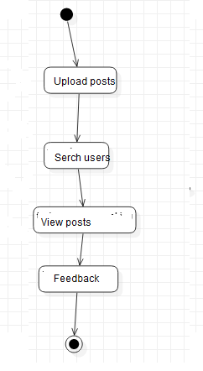

**State chart diagram :-**



## DATA DESIGN

* + 1. **Databases SQLite**

|  |
| --- |
| **Name** |
| Online depression |

**Table 3.10.1 SQLite Database**

* + 1. **Tables**

|  |  |
| --- | --- |
| **Name** | **Description** |
| Users | Contains all the registered user details. |
| Upload posts | All the registered service provider details. |
| Services | Contains all the types of services available. |

**Table 3.10.2 List of Database Tables**

## CONCLUSION

* In this paper, we tried to identify the presence of depression in Reddit social media; and searched for affective performance increase solutions of depression detection. We characterized a closer connection between depression and a language usage by applying NLP and text classification techniques. We identified a lexicon of words more common among the depressed accounts. According to our findings, the language predictors of depression contained the words related to preoccupation with themselves, feelings of sadness, anxiety, anger, hostility or suicidal thoughts, with a greater emphasis on the present and future

***CHAPTER - 4***

***SYSTEM LOWLEVEL DESIGN***

*This chapter gives an overview of all modules in the project.*

### CHAPTER 4

**SYSTEM LOWLEVEL DESIGN**

This chapter mainly provides the overview on modules of the application, objectives of the project and a detailed project overview.

* 1. **Modules of the Application:**
* **Admin Module:** Administrator will login to application using username as ‘admin’ and password ‘admin’. After login admin can view all registered users and all posts send by each users. Admin can send motivation messages to all depressed users. All positive and negative depression users can also be seen in the form of graph.
* **User Module:** Users need to register with the application and then login to application to access various sub modules such as
* **Search Friends:** Using this module user can see all peoples register with the application
* **Upload Posts**: Using this module user can upload post in various formats such as text file, image or audio file. This application accepts only .WAV file format.
* **View Motivation Messages:** Using this module users can view all motivation messages send by administrator.
  1. **OBJECTIVES OF THE PROJECT**

To implement this project we are using python Speech Recognition API which will read text from audio files and then SVM will analyse that text to detect depression, user can also upload images via post and python Tesseract OCR (Optical Character Recognition) API can read text from uploaded image and then SVM will detect depression from that text, User can upload post in text file also.

***CHAPTER - 5***

***IMPLEMENTATION***

*The chapter gives the details of the implementation.*

### CHAPTER 5 IMPLEMENTATION

This chapter mainly provides the sample code and implementation of the project.

* 1. **Sample Code**
     1. **XML Code for Bookings page**

*<?***xml version="1.0" encoding="utf-8"***?>*

<**LinearLayoutxmlns:android="**[**http://schemas.android.com/apk/res/android**](http://schemas.android.com/apk/res/android)**" android:layout_width="match_parent" android:layout_height="match_parent"**

**android:orientation="vertical"**>

<**android.support.v7.widget.LinearLayoutCompat android:layout_width="match_parent" android:layout_height="150dp" android:background="@color/colorTextHint" android:gravity="center" android:orientation="vertical"**>

<**android.support.v7.widget.AppCompatTextView android:layout_width="wrap_content" android:layout_height="wrap_content" android:text="Bookings" android:textSize="20sp"** />

<**android.support.v7.widget.AppCompatTextView android:layout_width="wrap_content" android:layout_height="wrap_content" android:layout_marginTop="10dp" android:text="@string/text_hello"** />

<**android.support.v7.widget.AppCompatTextView android:id="@+id/textViewName" android:layout_width="wrap_content" android:layout_height="wrap_content"** />

</**android.support.v7.widget.LinearLayoutCompat**>

<**android.support.v7.widget.AppCompatTextView android:layout_width="wrap_content" android:layout_height="wrap_content" android:paddingBottom="5dp" android:paddingLeft="16dp" android:paddingTop="5dp" android:text="Bookings" android:textColor="@android:color/black"** />

<**ScrollView android:id="@+id/scrollview" android:layout_width="fill_parent" android:layout_height="fill_parent" android:layout_below="@+id/spinner1" android:layout_alignParentBottom="true" android:layout_alignParentLeft="true"** >

<**LinearLayout android:layout_width="match_parent" android:layout_height="562dp" android:layout_marginBottom="200dp" android:orientation="vertical"** >

<**ListView**

**android:id="@+id/listView1" android:layout_width="wrap_content" android:layout_height="600dp" android:layout_marginLeft="0dp"** >

</**ListView**>

</**LinearLayout**>

</**ScrollView**>

</**LinearLayout**>

* + 1. **Java Code for Bookings page**

**package** com.example.spaceimpactor.houser.activities;

**import** java.util.ArrayList; **import** android.os.Bundle; **import** android.app.Activity; **import** android.content.Context; **import** android.content.Intent; **import** android.database.Cursor;

**import** android.database.sqlite.SQLiteDatabase;

**import** android.view.View;

**import** android.view.View.OnClickListener; **import** android.widget.AdapterView; **import** android.widget.ArrayAdapter; **import** android.widget.Button;

**import** android.widget.EditText; **import** android.widget.ImageView; **import** android.widget.ListView; **import** android.widget.Spinner; **import** android.widget.TextView;

**import** android.widget.AdapterView.OnItemClickListener;

**import** android.widget.Toast;

**import** com.example.spaceimpactor.houser.R;

**public class** Bookings **extends** Activity{ Spinner **sp**;

ImageView**out**; TextView**aaa**; SQLiteDatabase**db**; ListView**l**; EditText**t1**;

ArrayList<String>**list1**; ArrayAdapter**adapter**;

Button **sub**;

String **lmb**,**lser**,**lem**;

@Override

**protected void** onCreate(Bundle savedInstanceState) { **super**.onCreate(savedInstanceState); setContentView(R.layout.***activity_bookings***);

**final** GlobalClassglobalvariabel=(GlobalClass)getApplicationContext(); **aaa**=(TextView)findViewById(R.id.***textViewName***); **aaa**.setText(globalvariabel.GetUsername().toString());

**db**=openOrCreateDatabase(**"ServiceProvider"**, Context.***MODE_PRIVATE***, **null**); **l** = (ListView) findViewById(R.id.***listView1***);

**final** ArrayList<String> list = **new** ArrayList<String>();

**list1** = **new** ArrayList<String>();

Cursor res = **db**.rawQuery(**"SELECT * FROM book where uid='"** + **aaa**.getText() + **"'"**, **null**); **if** (res.getCount() != 0) {

**while** (res.moveToNext()) {

list.add(**"Name: "** + res.getString(1) + **"\nMobile No: "** + res.getString(2) + **"\n"** + **"Service Type: "** + res.getString(3) + **"\n"** + **"Email: "** + res.getString(4)+ **"\n"** + **"Booking Date: "** + res.getString(5));

**list1**.add(res.getString(1));

}

}

**adapter** = **new** ArrayAdapter<String>(**this**, android.R.layout.***simple_list_item_1***, list);

**l**.setAdapter(**adapter**);

}

}

* + 1. **Java Code for Profile Fragment**

**package** com.example.spaceimpactor.houser.fragment;

**import** android.content.Context;

**import** android.content.Intent;

**import** android.database.sqlite.SQLiteDatabase;

**import** android.os.Bundle;

**import** android.support.annotation.NonNull; **import** android.support.v4.app.Fragment; **import** android.text.TextUtils;

**import** android.util.Log;

**import** android.view.LayoutInflater;

**import** android.view.View;

**import** android.view.ViewGroup;

**import** android.support.annotation.Nullable;

**import** android.support.design.widget.Snackbar;

**import** android.support.design.widget.TextInputEditText; **import** android.support.design.widget.TextInputLayout; **import** android.support.v4.widget.NestedScrollView; **import** android.support.v7.app.AppCompatActivity; **import** android.support.v7.widget.AppCompatButton; **import** android.support.v7.widget.AppCompatTextView; **import** android.widget.Button;

**import** android.widget.EditText; **import** android.widget.ProgressBar; **import** android.widget.TextView; **import** android.widget.Toast;

**import** com.google.firebase.auth.FirebaseAuth; **import** com.google.firebase.auth.FirebaseUser; **import** com.google.firebase.database.DataSnapshot; **import** com.google.firebase.database.DatabaseError;

**import** com.google.firebase.database.DatabaseReference; **import** com.google.firebase.database.FirebaseDatabase; **import** com.google.firebase.database.ValueEventListener;

**public class** ProfileFragment**extends** Fragment **implements** View.OnClickListener {

**private** NestedScrollView**nestedScrollView**;

**private** TextInputLayout**textInputLayoutName**; **private** TextInputLayout**textInputLayoutPhone**; **private** TextInputLayout**textInputLayoutEmail**; **private** TextInputLayout**textInputLayoutPassword**;

**private** TextInputLayout**textInputLayoutConfirmPassword**;

**private** TextInputEditText**textInputEditTextName**; **private** TextInputEditText**textInputEditTextPhone**; **private** TextInputEditText**textInputEditTextEmail**; **private** TextInputEditText**textInputEditTextPassword**;

**private** TextInputEditText**textInputEditTextConfirmPassword**;

**private** AppCompatButton**appCompatButtonRegister**;

**private** InputValidation**inputValidation**; **private** DatabaseHelper**databaseHelper**; **private** User **user**;

EditText**id**,**ps**,**em**,**mb**; Button **sub**;

SQLiteDatabase**db**; TextView**aaa**;

**private static final** String ***TAG*** = MainActivity.**class**.getSimpleName();

**private** TextView**txtDetails**;

**private** EditText**inputName**, **inputEmail**; **private** Button **btnSave**;

**private** DatabaseReference**mFirebaseDatabase**;

**private** FirebaseDatabase**mFirebaseInstance**;

**private** String **userId**;

**private** Button **btnChangeEmail**, **btnChangePassword**, **btnSendResetEmail**, **btnRemoveUser**, **changeEmail**, **changePassword**, **sendEmail**, **remove**, **signOut**;

**private** EditText**oldEmail**, **newEmail**, **password**, **newPassword**; **private** ProgressBar**progressBar**;

**private** FirebaseAuth.AuthStateListener**authListener**;

**private** FirebaseAuth**auth**;

@Override

**public** View onCreateView(LayoutInflaterinflater, ViewGroup container, Bundle savedInstanceState) {

*// Inflate the layout for this fragment*

View myView = inflater.inflate(R.layout.***fragment_profile***, container, **false**);

*// appCompatButtonRegister = (AppCompatButton) myView.findViewById(R.id.appCompatButtonRegister);*

*// appCompatButtonRegister.setOnClickListener(this);*

**return** myView;

}

**private void** createUser(String name, String email) {

*//* ***TODO***

*// In real apps this userId should be fetched*

*// by implementing firebase auth*

**if** (TextUtils.*isEmpty*(**userId**)) {

**userId**= **mFirebaseDatabase**.push().getKey();

}

User user = **new** User();

**mFirebaseDatabase**.child(**userId**).setValue(user); addUserChangeListener();

}

*/\*\**

* *User data change listener*

*\*/*

**private void** addUserChangeListener() {

*// User data change listener* **mFirebaseDatabase**.child(**userId**).addValueEventListener(**new** ValueEventListener() { @Override

**public void** onDataChange(DataSnapshotdataSnapshot) { User user = dataSnapshot.getValue(User.**class**);

*// Check for null*

**if** (user == **null**) {

Log.*e*(***TAG***, **"User data is null!"**); **return**;

}

**inputEmail**.setText(**""**); **inputName**.setText(**""**);

}

@Override

**public void** onCancelled(DatabaseError error) {

*// Failed to read value*

Log.*e*(***TAG***, **"Failed to read user"**, error.toException());

}

});

}

**private void** updateUser(String name, String email) {

*// updating the user via child nodes*

**if** (!TextUtils.*isEmpty*(name))

**mFirebaseDatabase**.child(**userId**).child(**"name"**).setValue(name);

**if** (!TextUtils.*isEmpty*(email))

**mFirebaseDatabase**.child(**userId**).child(**"email"**).setValue(email);

}

*//sign out method* **public void** signOut() { **auth**.signOut();

}

@Override

**public void** onResume() { **super**.onResume(); **progressBar**.setVisibility(View.***GONE***);

}

@Override

**public void** onStart() {

**super**.onStart(); **auth**.addAuthStateListener(**authListener**);

}

@Override

**public void** onStop() {

**super**.onStop();

**if** (**authListener**!= **null**) {

**auth**.removeAuthStateListener(**authListener**);

}

}

**public void** onViewCreated(@NonNullView view, @NullableBundle savedInstanceState) {

**super**.onViewCreated(view, savedInstanceState);

*// initViews();*

*// initObjects();*

**auth**= FirebaseAuth.*getInstance*();

*//get current user*

**final** FirebaseUser user = FirebaseAuth.*getInstance*().getCurrentUser();

**authListener**= **new** FirebaseAuth.AuthStateListener() { @Override

**public void** onAuthStateChanged(@NonNullFirebaseAuthfirebaseAuth) { FirebaseUser user = firebaseAuth.getCurrentUser();

**if** (user == **null**) {

*// user auth state is changed - user is null*

*// launch login activity*

startActivity(**new** Intent(getActivity(), LoginActivity.**class**));

}

}

};

*// btnChangeEmail = (Button) findViewById(R.id.change_email_button);*

*//btnChangePassword = (Button) findViewById(R.id.change_password_button);* **btnSendResetEmail**= (Button) getView().findViewById(R.id.***sending_pass_reset_button***); **btnRemoveUser**= (Button) getView().findViewById(R.id.***remove_user_button***);

*// changeEmail = (Button) getView().findViewById(R.id.changeEmail);*

*// changePassword = (Button) getView().findViewById(R.id.changePass);*

**sendEmail**= (Button) getView().findViewById(R.id.***send***); **remove** = (Button) getView().findViewById(R.id.***remove***); **signOut**= (Button) getView().findViewById(R.id.***sign_out***);

**oldEmail**= (EditText) getView().findViewById(R.id.***old_email***); **newEmail**= (EditText) getView().findViewById(R.id.***new_email***); **password** = (EditText) getView().findViewById(R.id.***password***); **newPassword**= (EditText) getView().findViewById(R.id.***newPassword***);

**oldEmail**.setVisibility(View.***GONE***); **newEmail**.setVisibility(View.***GONE***); **password**.setVisibility(View.***GONE***); **newPassword**.setVisibility(View.***GONE***);

*// changeEmail.setVisibility(View.GONE);*

*// changePassword.setVisibility(View.GONE);* **sendEmail**.setVisibility(View.***GONE***); **remove**.setVisibility(View.***GONE***);

**progressBar**= (ProgressBar) getView().findViewById(R.id.***progressBar***);

**if** (**progressBar**!= **null**) {

**progressBar**.setVisibility(View.***GONE***);

}

**btnSendResetEmail**.setOnClickListener(**new** View.OnClickListener() { @Override

**public void** onClick(View v) { **oldEmail**.setVisibility(View.***VISIBLE***); **newEmail**.setVisibility(View.***GONE***); **password**.setVisibility(View.***GONE***); **newPassword**.setVisibility(View.***GONE***);

*// changeEmail.setVisibility(View.GONE);*

*// changePassword.setVisibility(View.GONE);* **sendEmail**.setVisibility(View.***VISIBLE***); **remove**.setVisibility(View.***GONE***);

}

});

**sendEmail**.setOnClickListener(**new** View.OnClickListener() { @Override

**public void** onClick(View v) {

**progressBar**.setVisibility(View.***VISIBLE***);

**if** (!**oldEmail**.getText().toString().trim().equals(**""**)) {

**auth**.sendPasswordResetEmail(**oldEmail**.getText().toString().trim())

.addOnCompleteListener(**new** OnCompleteListener<Void>() {

@Override

**public void** onComplete(@NonNullTask<Void> task) {

**if** (task.isSuccessful()) {

Toast.*makeText*(getActivity(), **"Reset password email is sent!"**, Toast.***LENGTH_SHORT***).show();

**progressBar**.setVisibility(View.***GONE***);

} **else** {

Toast.*makeText*(getActivity(), **"Failed to send reset email!"**, Toast.***LENGTH_SHORT***).show();

**progressBar**.setVisibility(View.***GONE***);

}

}

});

} **else** {

**oldEmail**.setError(**"Enter email"**); **progressBar**.setVisibility(View.***GONE***);

}

}

});

**btnRemoveUser**.setOnClickListener(**new** View.OnClickListener() { @Override

**public void** onClick(View v) {

**progressBar**.setVisibility(View.***VISIBLE***);

**if** (user != **null**) { user.delete()

@Override

.addOnCompleteListener(**new** OnCompleteListener<Void>() {

**public void** onComplete(@NonNullTask<Void> task) {

**if** (task.isSuccessful()) {

Toast.*makeText*(getActivity(), **"Your profile is deleted:( Create a account now!"**, Toast.***LENGTH_SHORT***).show(); startActivity(**new** Intent(getActivity(), RegisterActivity.**class**));

*// finish();*

**progressBar**.setVisibility(View.***GONE***);

} **else** {

Toast.*makeText*(getActivity(), **"Failed to delete your account!"**, Toast.***LENGTH_SHORT***).show();

**progressBar**.setVisibility(View.***GONE***);

}

}

});

}

}

});

**signOut**.setOnClickListener(**new** View.OnClickListener() { @Override

**public void** onClick(View v) { signOut();

}

});

*//txtDetails = (TextView) findViewById(R.id.txt_user);* **inputName**= (EditText) getView().findViewById(R.id.***name***); **inputEmail**= (EditText) getView().findViewById(R.id.***email***); **btnSave**= (Button) getView().findViewById(R.id.***btn_save***);

**mFirebaseInstance**= FirebaseDatabase.*getInstance*();

*// get reference to 'users' node*

**mFirebaseDatabase**= **mFirebaseInstance**.getReference(**"users"**);

*// store app title to 'app_title' node*

**mFirebaseInstance**.getReference(**"app_title"**).setValue(**"Houser"**);

*// app_title change listener* **mFirebaseInstance**.getReference(**"app_title"**).addValueEventListener(**new** ValueEventListener() { @Override

**public void** onDataChange(DataSnapshotdataSnapshot) { Log.*e*(***TAG***, **"App title updated"**);

String appTitle = dataSnapshot.getValue(String.**class**);

*// update toolbar title*

*//getSupportActionBar().setTitle(appTitle);*

}

@Override

**public void** onCancelled(DatabaseError error) {

*// Failed to read value*

Log.*e*(***TAG***, **"Failed to read app title value."**, error.toException());

}

});

*// Save / update the user* **btnSave**.setOnClickListener(**new** View.OnClickListener() { @Override

**public void** onClick(View view) {

String name = **inputName**.getText().toString(); String email = **inputEmail**.getText().toString();

*// Check for already existed userId* **if** (TextUtils.*isEmpty*(**userId**)) { createUser(name, email);

} **else** {

updateUser(name, email);

}

}

});

}

@Override

**public void** onClick(View v) { postDataToSQLite();

}

**private void** initViews() {

**nestedScrollView**= (NestedScrollView) getView().findViewById(R.id.***nestedScrollView***);

**textInputLayoutName**= (TextInputLayout) getView().findViewById(R.id.***textInputLayoutName***); **textInputLayoutPhone**= (TextInputLayout) getView().findViewById(R.id.***textInputLayoutPhone***); **textInputLayoutEmail**= (TextInputLayout) getView().findViewById(R.id.***textInputLayoutEmail***); **textInputLayoutPassword**= (TextInputLayout) getView().findViewById(R.id.***textInputLayoutPassword***); **textInputLayoutConfirmPassword**= (TextInputLayout) getView().findViewById(R.id.***textInputLayoutConfirmPassword***);

**textInputEditTextName**= (TextInputEditText) getView().findViewById(R.id.***textInputEditTextName***); **textInputEditTextPhone**= (TextInputEditText) getView().findViewById(R.id.***textInputEditTextPhone***); **textInputEditTextEmail**= (TextInputEditText) getView().findViewById(R.id.***textInputEditTextEmail***); **textInputEditTextPassword**= (TextInputEditText) getView().findViewById(R.id.***textInputEditTextPassword***); **textInputEditTextConfirmPassword**= (TextInputEditText) getView().findViewById(R.id.***textInputEditTextConfirmPassword***);

}

**private void** initObjects() {

**inputValidation**= **new** InputValidation(getActivity()); **databaseHelper**= **new** DatabaseHelper(getActivity()); **user** = **new** User();

}

**private void** postDataToSQLite() {

**if** (!**inputValidation**.isInputEditTextFilled(**textInputEditTextName**, **textInputLayoutName**, getString(R.string.***error_message_name***))) {

**return**;

}

**if** (!**inputValidation**.isInputEditTextFilled(**textInputEditTextPhone**, **textInputLayoutPhone**, **"Enter Phone Number"**)) {

**return**;

}

**if** (!**inputValidation**.isInputEditTextFilled(**textInputEditTextEmail**, **textInputLayoutEmail**, getString(R.string.***error_message_email***))) {

**return**;

}

**if** (!**inputValidation**.isInputEditTextFilled(**textInputEditTextEmail**, **textInputLayoutEmail**, getString(R.string.***error_message_email***))) {

**return**;

}

**if** (!**inputValidation**.isInputEditTextEmail(**textInputEditTextEmail**, **textInputLayoutEmail**, getString(R.string.***error_message_email***))) {

**return**;

}

**if** (!**inputValidation**.isInputEditTextPhone(**textInputEditTextPhone**, **textInputLayoutPhone**, getString(R.string.***error_message_phone***))) {

**return**;

}

**if** (!**inputValidation**.isInputEditTextFilled(**textInputEditTextPassword**, **textInputLayoutPassword**,

getString(R.string.***error_message_password***))) {

**return**;

}

**if** (!**inputValidation**.isInputEditTextMatches(**textInputEditTextPassword**, **textInputEditTextConfirmPassword**, **textInputLayoutConfirmPassword**, getString(R.string.***error_password_match***))) {

**return**;

}

**if** (!**databaseHelper**.checkUser(**textInputEditTextEmail**.getText().toString().trim())) {

**user**.setName(**textInputEditTextName**.getText().toString().trim()); **user**.setPhone(**textInputEditTextPhone**.getText().toString().trim()); **user**.setEmail(**textInputEditTextEmail**.getText().toString().trim()); **user**.setPassword(**textInputEditTextPassword**.getText().toString().trim());

**databaseHelper**.updateUser(**user**); emptyInputEditText();

}

}

**private void** emptyInputEditText()

{

**textInputEditTextName**.setText(**null**); **textInputEditTextPhone**.setText(**null**); **textInputEditTextEmail**.setText(**null**); **textInputEditTextPassword**.setText(**null**); **textInputEditTextConfirmPassword**.setText(**null**);

}

}

**5.1.3 XML Code for Profile Fragment**

*<?***xml version="1.0" encoding="utf-8"***?>*

<**android.support.v4.widget.NestedScrollView xmlns:android="**[**http://schemas.android.com/apk/res/android**](http://schemas.android.com/apk/res/android)**" xmlns:tools="**[**http://schemas.android.com/tools**](http://schemas.android.com/tools)**"**

**xmlns:app="**[**http://schemas.android.com/apk/res-auto**](http://schemas.android.com/apk/res-auto)**" android:id="@+id/nestedScrollView" android:layout_width="match_parent" android:layout_height="match_parent" android:paddingBottom="20dp" android:paddingLeft="20dp" android:paddingRight="20dp" android:paddingTop="20dp"**>

<**LinearLayout android:layout_width="match_parent" android:layout_height="wrap_content" android:orientation="vertical"**

**android:paddingBottom="@dimen/activity_vertical_margin" android:paddingLeft="@dimen/activity_horizontal_margin" android:paddingRight="@dimen/activity_horizontal_margin" android:paddingTop="0dp" app:layout_behavior="@string/appbar_scrolling_view_behavior"**>

<**TextView android:layout_width="match_parent" android:layout_height="match_parent"**

**android:text="Update your Profile" android:textColor="@android:color/black" android:textStyle="bold" android:textSize="30sp" android:layout_marginBottom="70dp" android:gravity="center"**/>

<**EditText android:id="@+id/old_email" android:layout_width="match_parent" android:layout_height="wrap_content" android:hint="Confirm Email"**

**android:inputType="textEmailAddress" android:maxLines="1" android:singleLine="true"** />

<**EditText android:id="@+id/new_email" android:layout_width="match_parent" android:layout_height="wrap_content" android:hint="New Email" android:inputType="textEmailAddress" android:maxLines="1" android:singleLine="true"** />

<**EditText android:id="@+id/password" android:layout_width="match_parent" android:layout_height="wrap_content" android:focusableInTouchMode="true" android:hint="@string/hint_password" android:imeActionId="@+id/login"**

**android:imeOptions="actionUnspecified" android:inputType="textPassword" android:maxLines="1" android:singleLine="true" tools:ignore="InvalidImeActionId"** />

<**EditText android:id="@+id/newPassword" android:layout_width="match_parent" android:layout_height="wrap_content" android:focusableInTouchMode="true" android:hint="New Password" android:imeActionId="@+id/login" android:imeOptions="actionUnspecified" android:inputType="textPassword" android:maxLines="1" android:singleLine="true" tools:ignore="InvalidImeActionId"** />

<**Button android:id="@+id/send"**

**style="?android:textAppearanceSmall" android:layout_width="wrap_content" android:layout_height="wrap_content" android:layout_marginTop="16dp" android:background="@android:color/black" android:text="Send" android:textColor="@android:color/white" android:textStyle="bold" android:layout_gravity="end"**/>

<**ProgressBar android:id="@+id/progressBar" android:layout_width="30dp" android:layout_height="30dp" android:visibility="gone"** />

<**Button android:id="@+id/remove"**

**style="?android:textAppearanceSmall" android:layout_width="wrap_content" android:layout_height="wrap_content" android:layout_marginTop="16dp" android:background="@color/colorPrimaryDark" android:text="Remove" android:textColor="@android:color/white" android:textStyle="bold"** />

<**android.support.design.widget.TextInputLayout android:layout_width="match_parent" android:layout_height="wrap_content"**>

<**EditText android:id="@+id/name"**

**android:layout_width="match_parent" android:layout_height="wrap_content" android:hint="Name" android:inputType="textCapWords" android:maxLines="1"** />

</**android.support.design.widget.TextInputLayout**>

<**android.support.design.widget.TextInputLayout android:layout_width="match_parent" android:layout_height="wrap_content"**>

<**EditText android:id="@+id/email"**

**android:layout_width="match_parent" android:layout_height="wrap_content" android:hint="Email" android:inputType="textEmailAddress" android:maxLines="1"** />

</**android.support.design.widget.TextInputLayout**>

## Screen Captures

* + 1. **User Login Screen:**

Now deploy code in DJANGO and start server and run in browser to get below screen

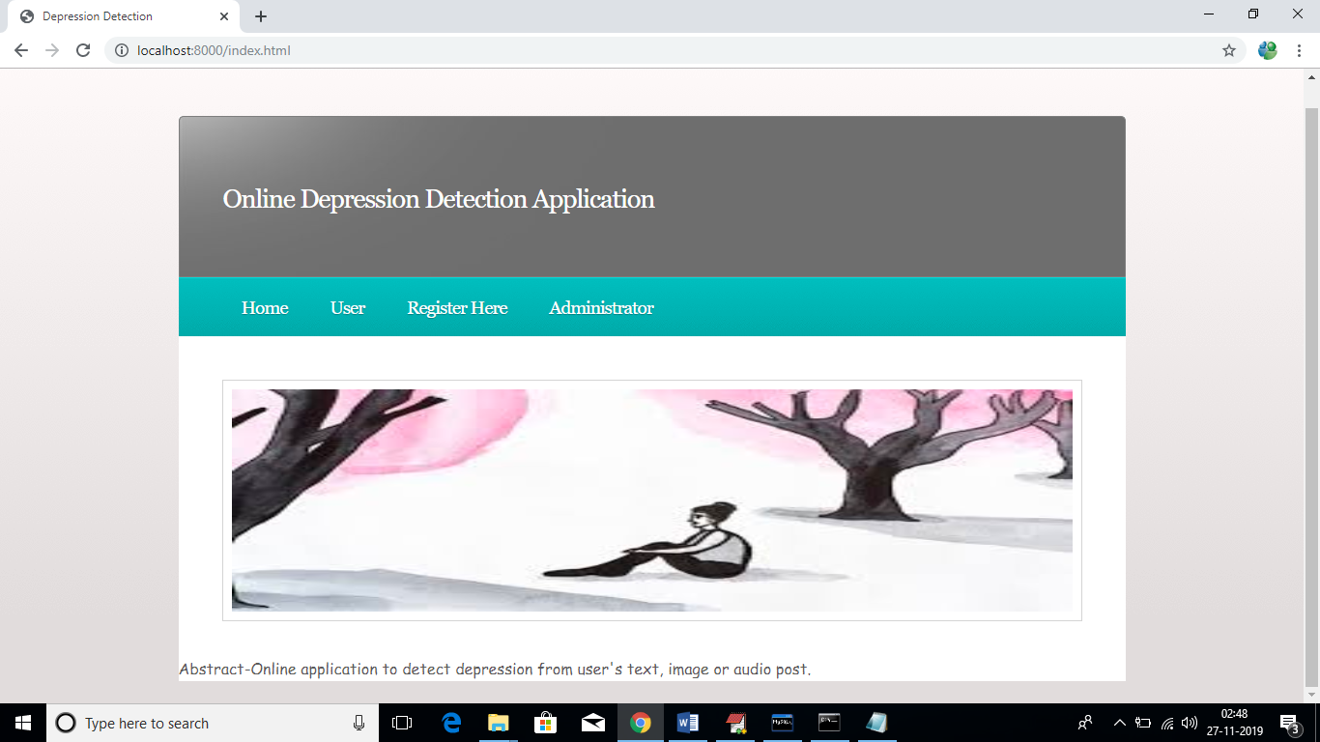

In above screen click on ‘Register Here’ link to add new user to application

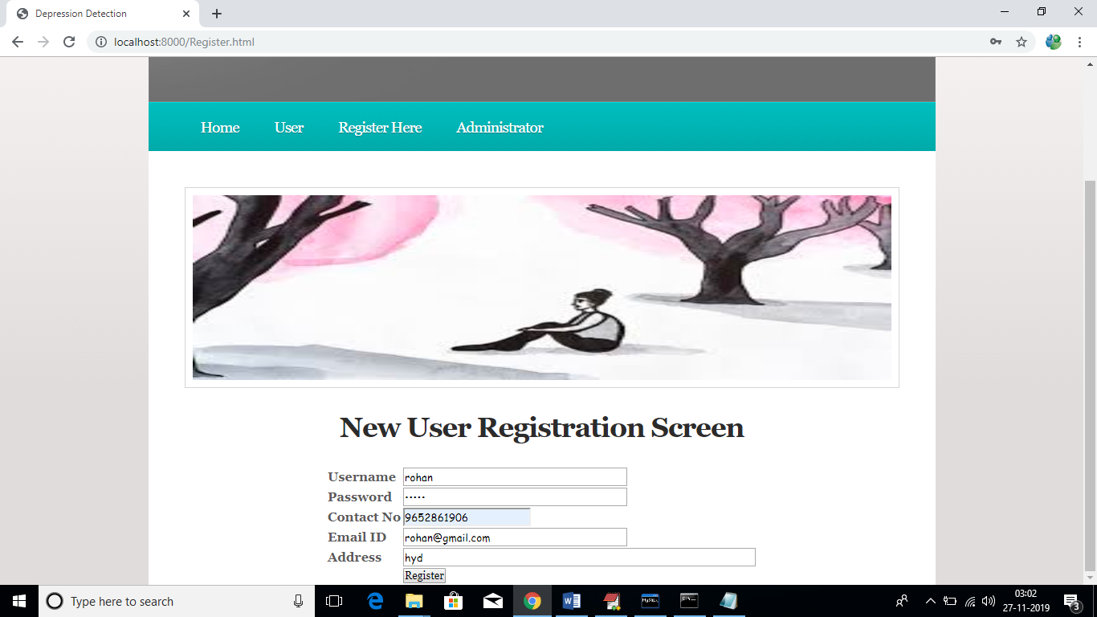

After register will get below confirmation screen

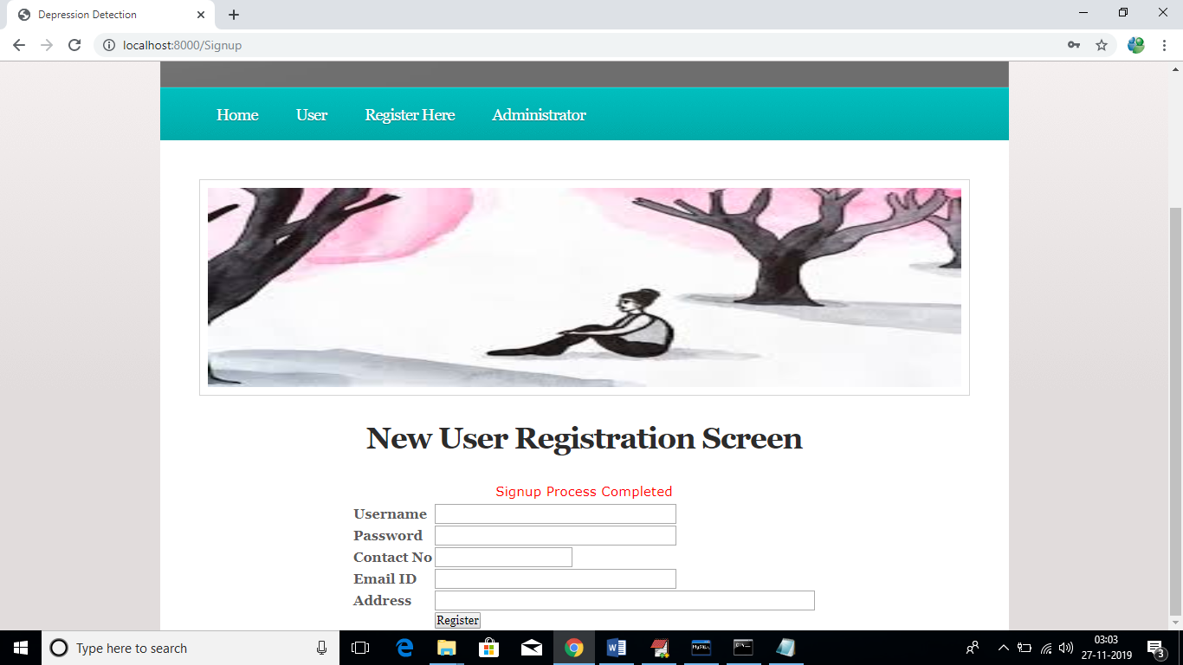

Now click on ‘User’ link to login as ‘user’

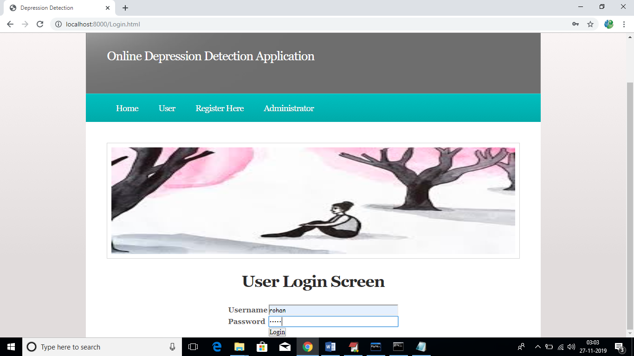

After login will get below user screen

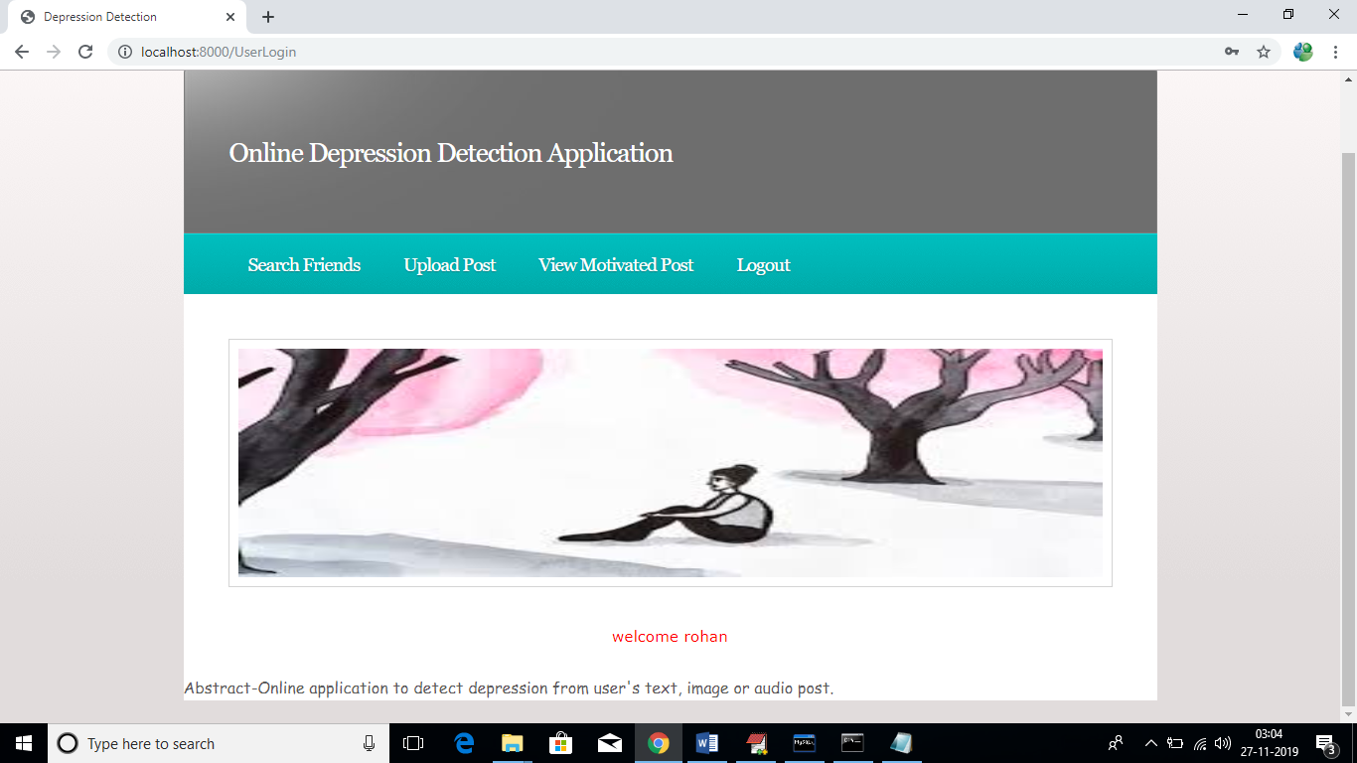

In above screen click on ‘Search Friends’ link to view all users registered with the application

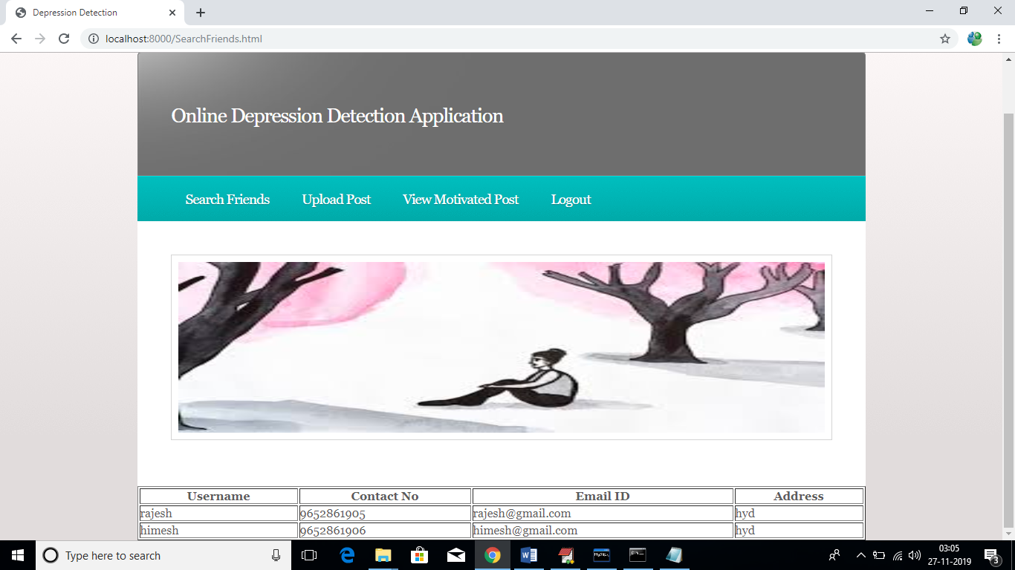

Now click on ‘Upload Post’ link to upload post files such as text, image or audio

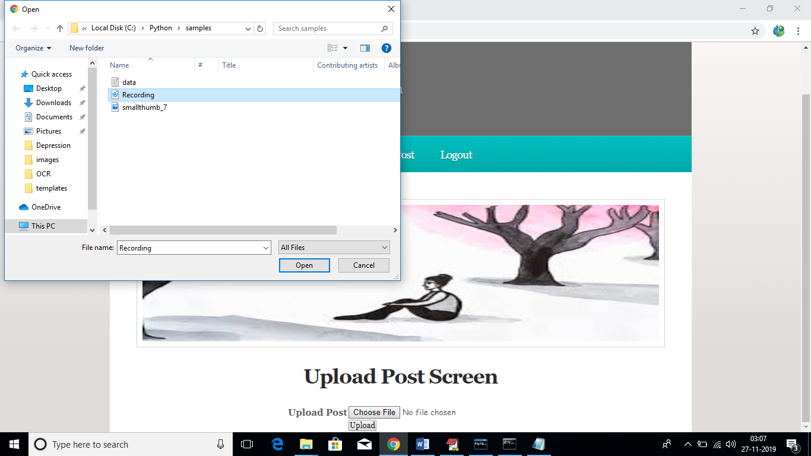

In above screen I am uploading one recording file, after upload will get below message from recording data

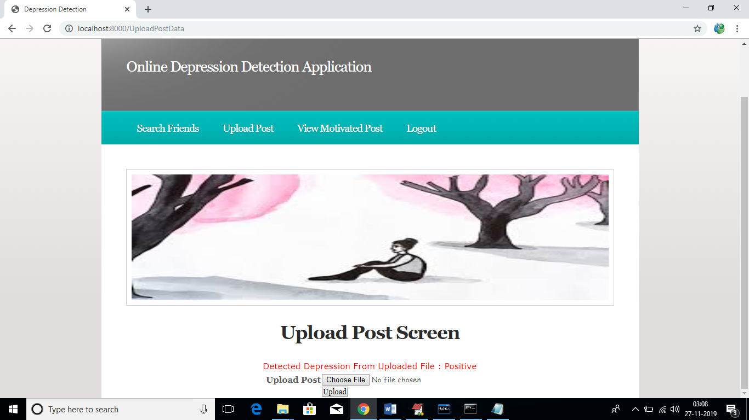

In above screen its says uploaded file contains message which indicate user is happy and gave positive recording. In below screen I am uploading one image which contains depress negative message

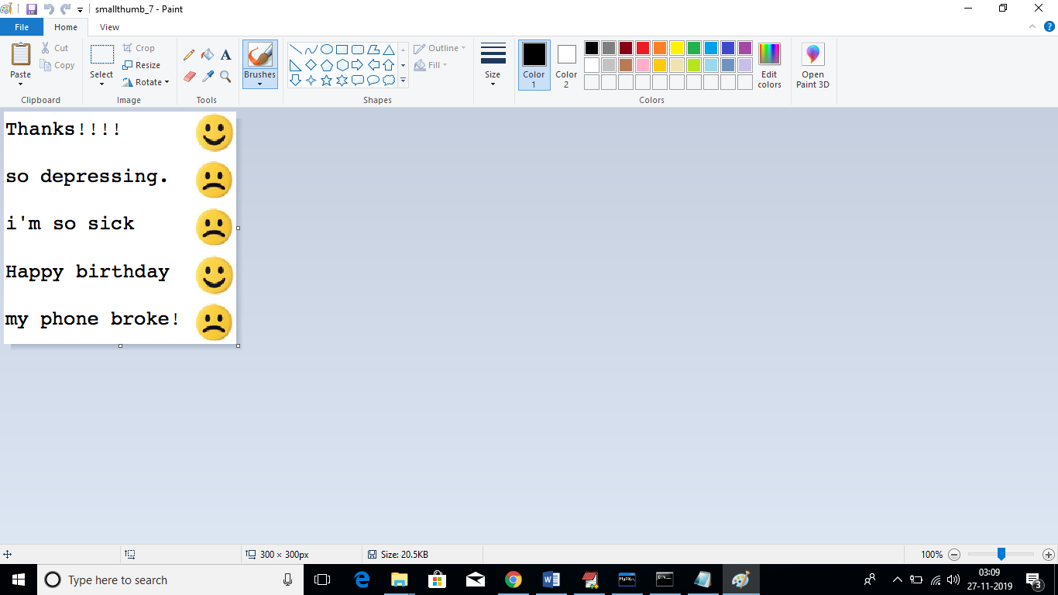

In above screen in title image file name is ‘smallthumb-7’ and it contains depress negative message and I will upload same image to application and see results

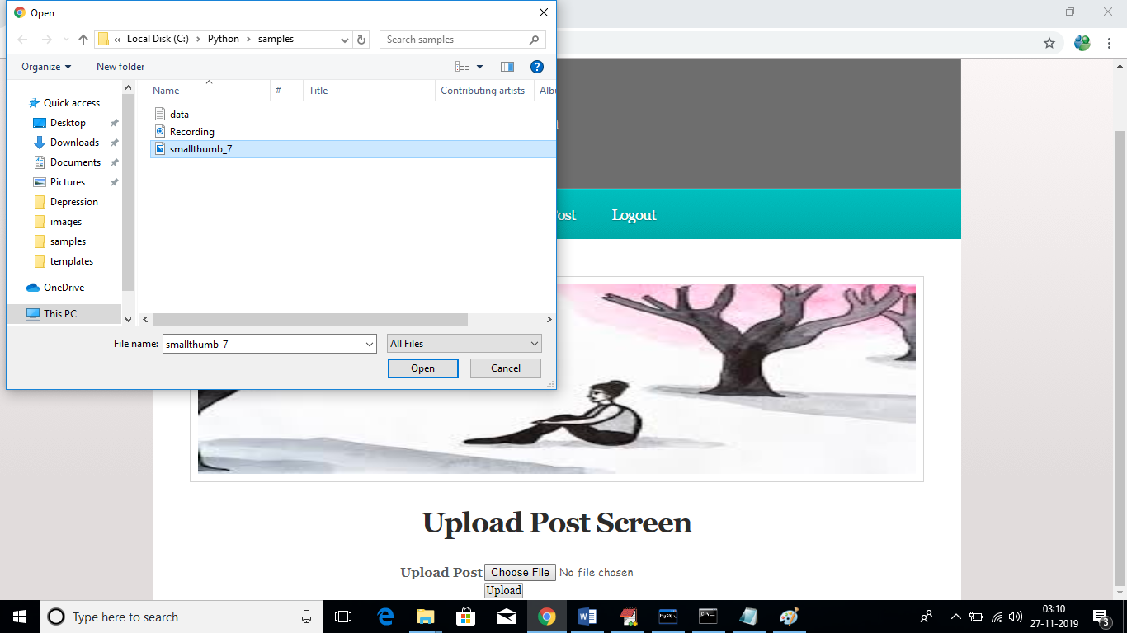

In above screen we can see I am uploading same image and below are is the output screen

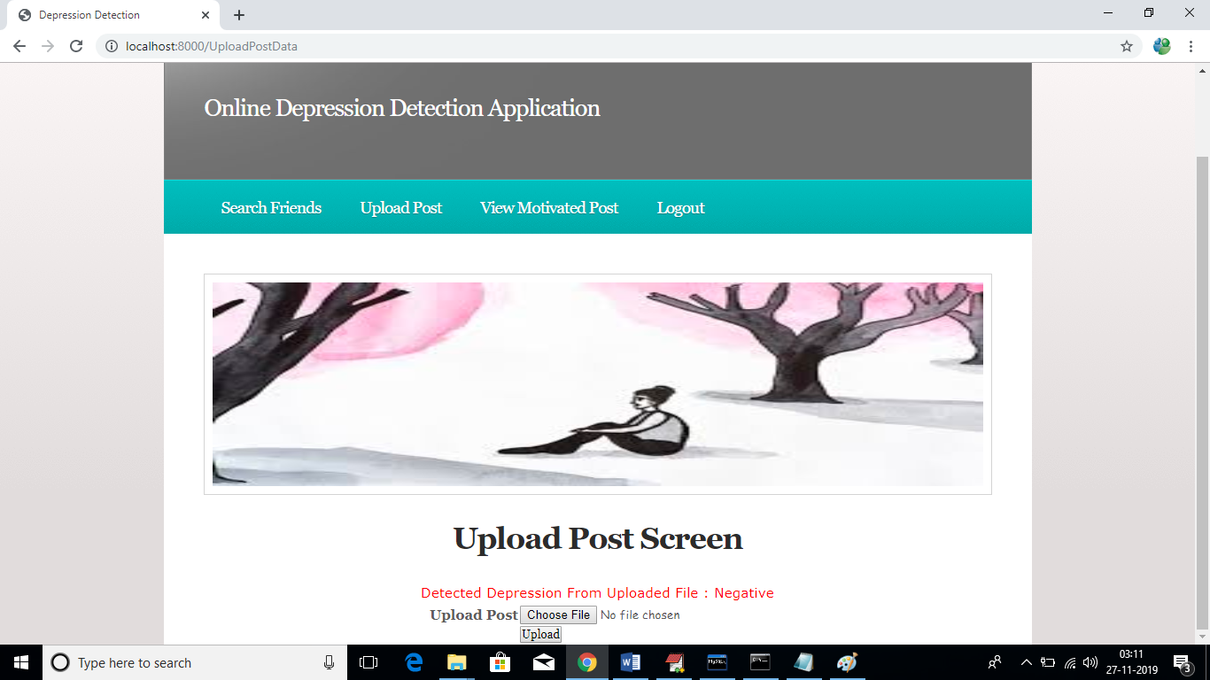

In above screen message is negative and we can say user is depressed. Similarly click on ‘View Motivated Post’ link to get admin message if he posted otherwise message will mark as ‘Pending’

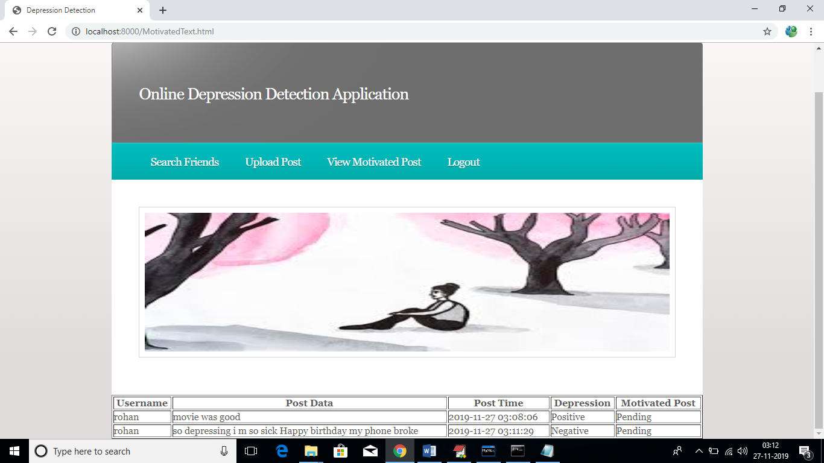

In above screen we can see this user uploaded two files one is recording and other one is image and both file data we can see as post data column and depression result as positive or negative also we can see. Admin has not sent any motivated post so the field is marked as ‘Pending’. Now logout and login as ‘admin’.

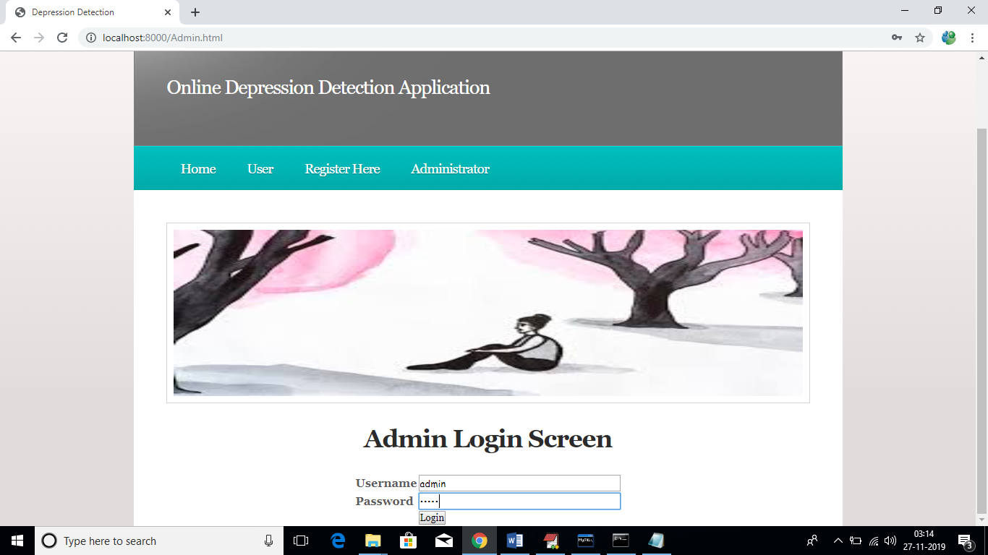

After login we can get below admin screen

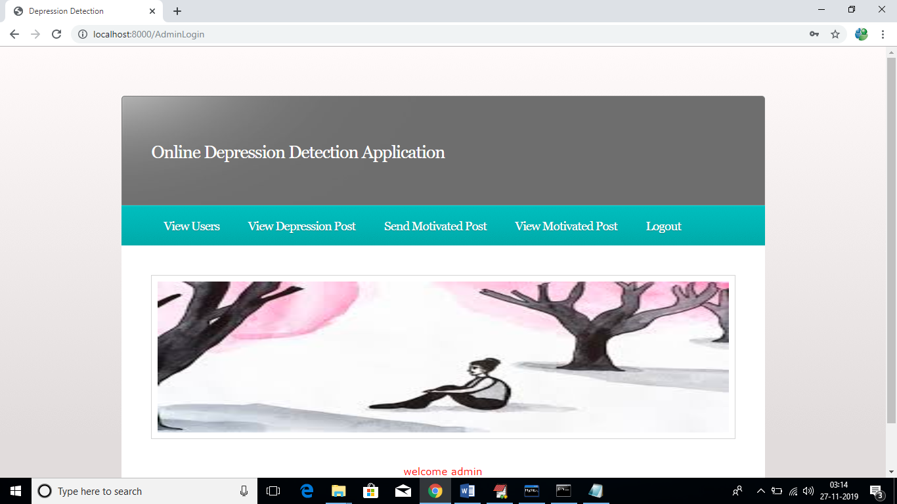

In above screen admin can click on ‘View Users’ to view all users list

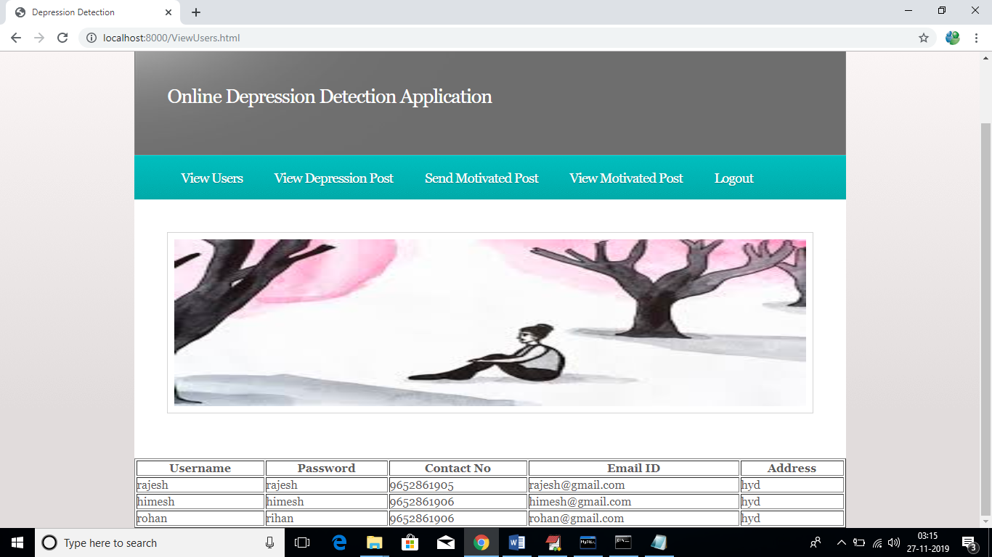

Similarly admin can click on ‘View Depression Post’ to view all post in graph and text format

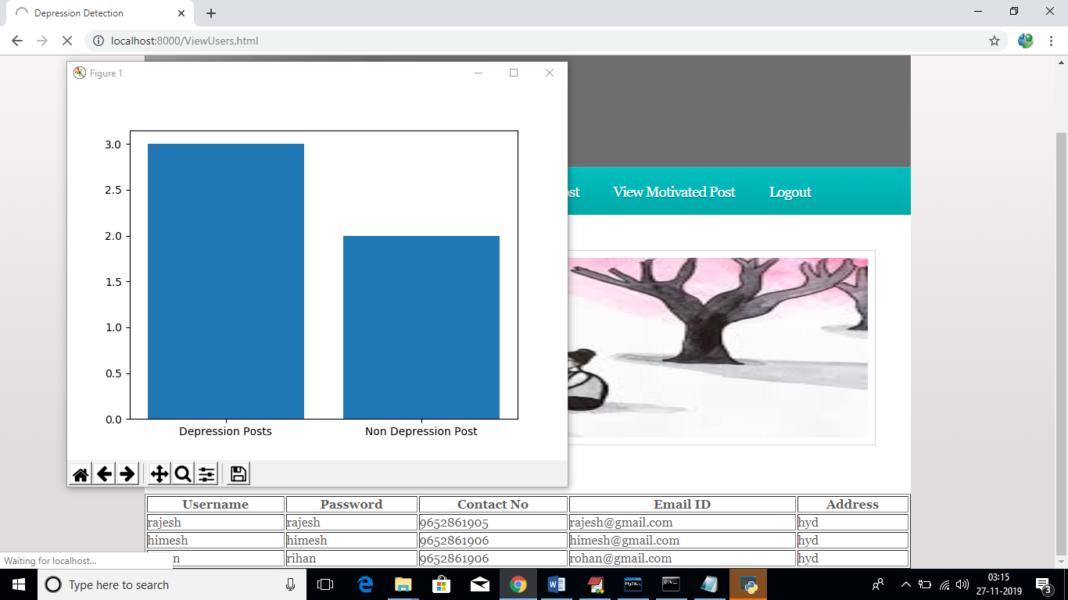

In above graph we can see total depress and non-depress users, see below screen for all posts from all users

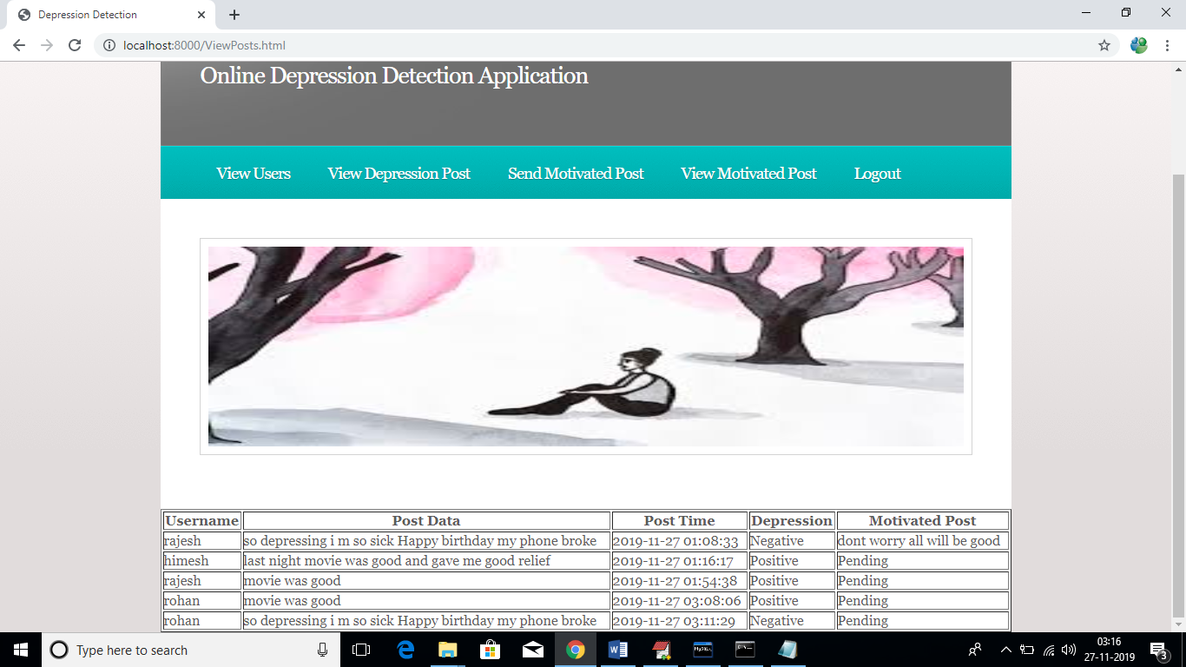

Similarly admin can click on ‘Send Motivated Post’ link to send motivated messages to users. While sending messages admin has to enter username and post time. Post time he can copy from above screen

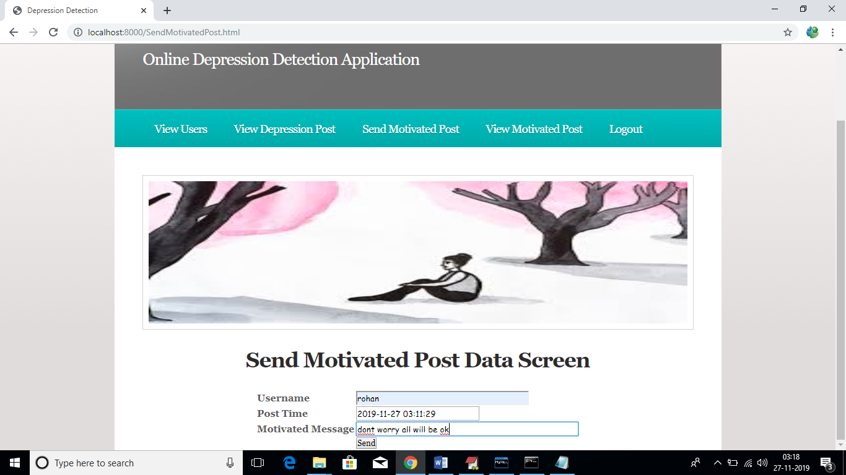

After sending motivated messages will get below screen

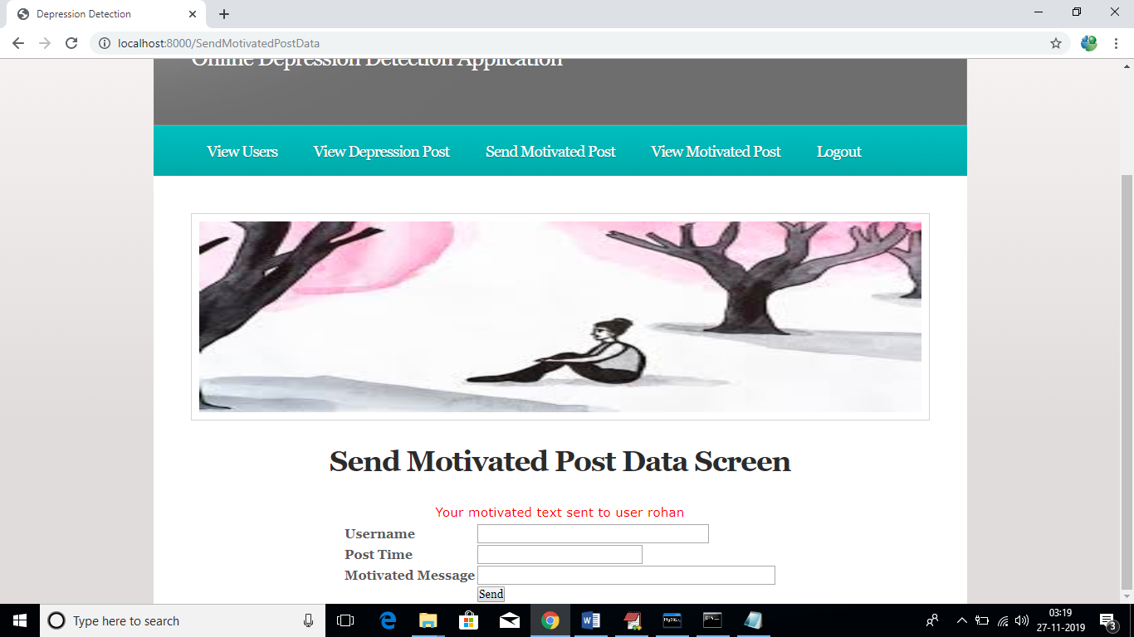

Now admin can click on ‘View Motivated Post’ link to view all motivated messages sent by him

***CHAPTER - 6***

***TESTING***

*The chapter shows the various test cases.*

# CHAPTER 6

## Software Testing

Software testing is the process of validating and verifying that a software applicationmeets the technical requirements which are involved in its design and development. It is alsoused to uncover any defects/bugs that exist in the application. It assures the quality of thesoftware. There are many types of testing software viz., manual testing, unit testing, black box testing, performance testing, stress testing, regression testing, white box testing etc. Among theseperformance testing and load testing are the most important one for an android application and nextsections deal with some of these types.

## Black box Testing

Black box testing treats the software as a "black box"—without any knowledge of internal implementation. Black box testing methods include equivalence partitioning, boundary value analysis, all-pairs testing, fuzz testing, model-based testing, traceability matrix, exploratory testing,and specification-based testing.

## White box Testing

White box testing is when the tester has access to the internal data structures and algorithms including the code that implement these.

## Performance Testing

Performance testing is executed to determine how fast a system or sub-system performsunder a particular workload. It can also serve to validate and verify other quality attributes of thesystem such as scalability, reliability and resource usage.

## Load Testing

Load testing is primarily concerned with testing that can continue to operate underspecific load, whether that is large quantities of data or a large number of users.

## Manual Testing

Manual Testing is the process of manually testing software for defects. Functionality of this application is manually tested to ensure the correctness. Few examples of test case for Manual Testing are discussed later in this chapter.

|  |  |
| --- | --- |
| **Test Case 1** | |
| Test Case Name | Empty login fields testing |
| Description | In the login screen if the username and password fields are empty |
| Output | Login fails showing an alert box asking to enter username and  password. |

**Table 6:1 Test Case for Empty Login Fields**

**Figure 6-1 Test Case for Empty Login Fields**

|  |  |
| --- | --- |
| **Test Case 2** | |
| Test Case Name | Wrong login fields testing |
| Description | A unique username and password are set by administrator. On entering wrong username or password gives. |
| Output | Login fails showing an alert box username or password  incorrect. |

**Table 6:2 Test Case for Wrong Login Fields**

**Figure 6-2 Test Case for Wrong Login Fields**

|  |  |
| --- | --- |
| **Test Case 3** | |
| Test Case Name | User Signup Fails. |
| Description | User signup need to provide all data. |
| Output | Signup Fails and an alert message appears asking to enter valid email and name. |

**Table 6:3 Test Case for Signup fail**

***CHAPTER - 7***

***RESULTS &CHALLENGES***

*The chapter describes the results and challenges faced in the project.*

# CHAPTER 7

**RESULTS AND CHALLENGES**

## Results

The current android application is developed using Xml, Java, SQL with Firebase connectivity. It can be used by every individual who are in a need of fulfilling their household services.

At the time of submission of my application was capable of doing the following:

* + Displaying thehome screen with different fragments.
  + Authentication of user by using login screen using Firebase.
  + Home screen to display based on user or service provider.
  + After successful login of user, they can choose the service and book a slot of their particular service provider from the displayed list.
  + Add, update, view, delete the user details.
  + After successful login of service provider, they can view all the bookings that are booked by the users and can attend them one by one.
  + Service provider can also set his preferences to not available, if he’s too busy or many users had already booked him.
  + Service provider has the ability to change their particular radius of location for servicing.
  + He can set up to 10 km radius.
  + Logout and end the session.

## Challenges

* + - Understanding the connections of SQLite Database is a tricky part and confusing when dealing with multiple tables within a database.
    - Making exact orientation API design levels was a difficult task as there are many types of devices like desktop, tablet, mobile with varying screen size and resolutions.
    - Implementing synchronization with Firebasewas a challenging task.
    - Learning different technologies and frameworks with little guidance.

***CHAPTER - 8***

***CONCLUSIONS & FUTURE WORK***

*The chapter gives brief conclusion about the project.*

# CHAPTER 8

# CONCLUSION

## Conclusion

## In this paper, we tried to identify the presence of depression in Reddit social media; and searched for affective performance increase solutions of depression detection. We characterized a closer connection between depression and a language usage by applying NLP and text classification techniques. We identified a lexicon of words more common among the depressed accounts. According to our findings, the language predictors of depression contained the words related to preoccupation with themselves, feelings of sadness, anxiety, anger, hostility or suicidal thoughts, with a greater emphasis on the present and future

## Scope for future work

## 

## the best feature among the single feature sets is bigram; with SVM classifier it can detect depression with 80% accuracy and 0.79 F1 score. Considering LIWC and LDA features, LIWC outperformed topic models generated by LDA.

## 

## Limitations

* T. Fabian, “Online depression detection in Proc. Comput. Inf. Syst. Ind. Manage. Appl., Jun. 2008, pp. 165170.

# BIBLIOGRAPHY

Code snippets for any errors <http://stackoverflow.com/>

Android Development Guide htt[ps://www](http://www.udemy.com/android).[udemy.com/android](http://www.udemy.com/android)

Xml and Layout Guide htt[ps://www](http://www.androidhive.com/).[androidhive.com/](http://www.androidhive.com/)

Connecting to Firebase Docs https://firebase.google.com

Software Testing <http://en.wikipedia.org/wiki/Software_testing>

Manual Testing <http://en.wikipedia.org/wiki/Manual_testing>

Performance Testing <http://en.wikipedia.org/wiki/Software_performance_testing>